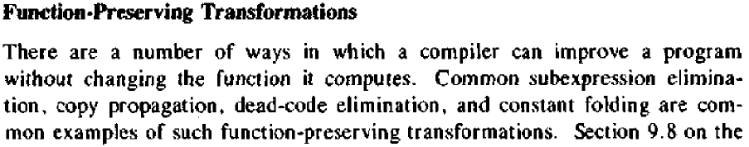
Code optimization:
1. Local common sub expression elimination
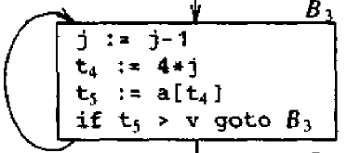
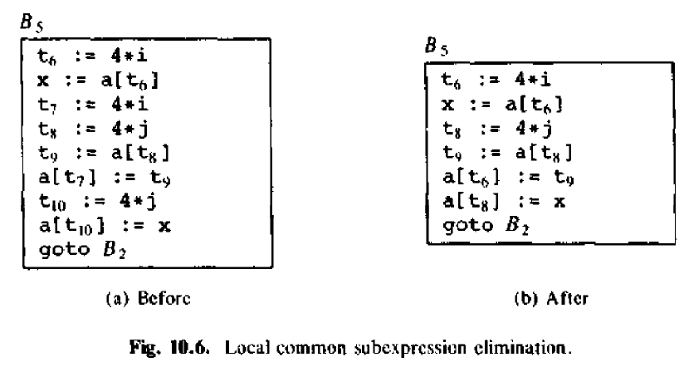
2. Global Common subexpressions elimination
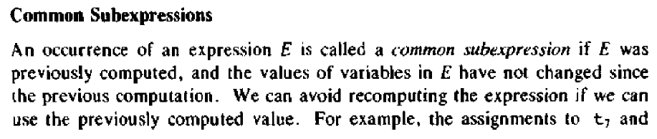
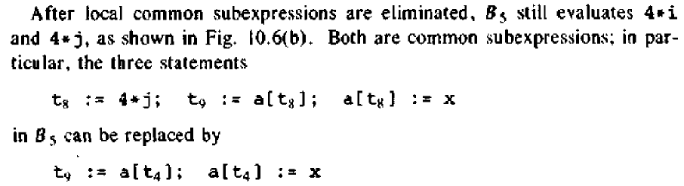
3. Copy Propagation
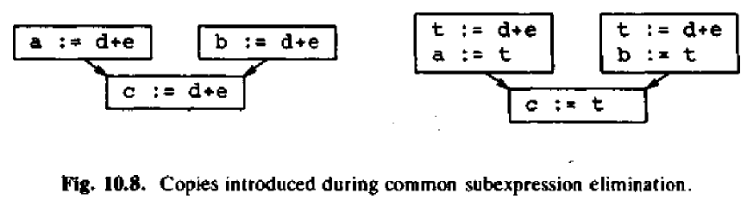
Assignment of same expression repeats in multiple blocks to multiple variables.
In block 5
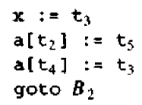
Simply remove assignment to x.
4. Dead code elimination
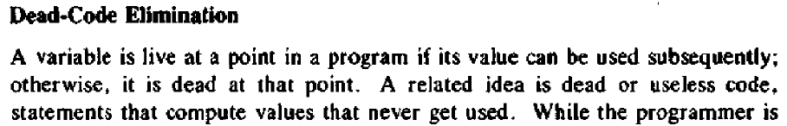
Example 1:
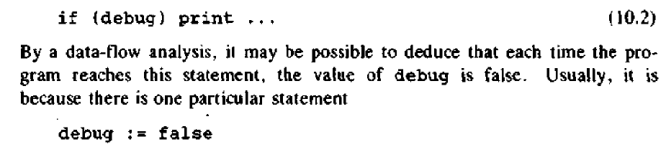
Example 2:
Block 5 is
If x is not used to other following blocks, it could be minimized as

5. Loop Optimization
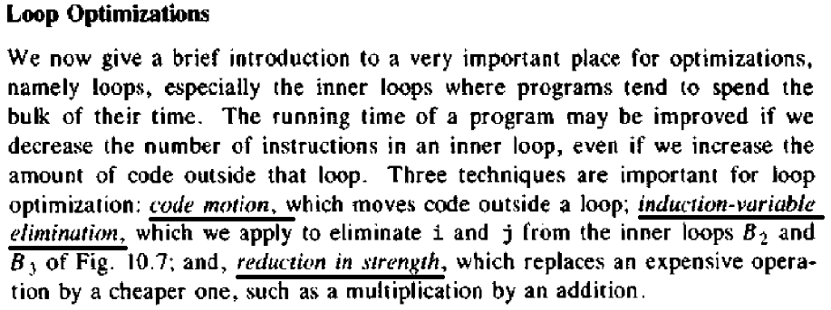
5.1 Code Motion
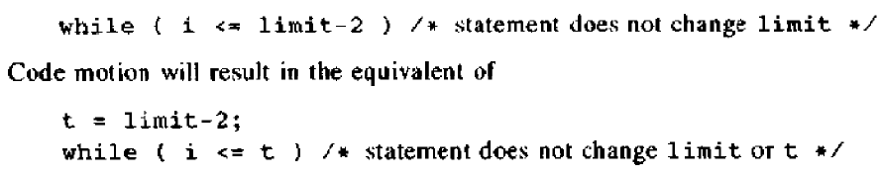
5.2

